MOBILE COMPUTING
LAB EXPERIMENT 15
15.Develop a wireframe for a mobile application that addresses challenges related to ad hoc wireless networks using Figma.

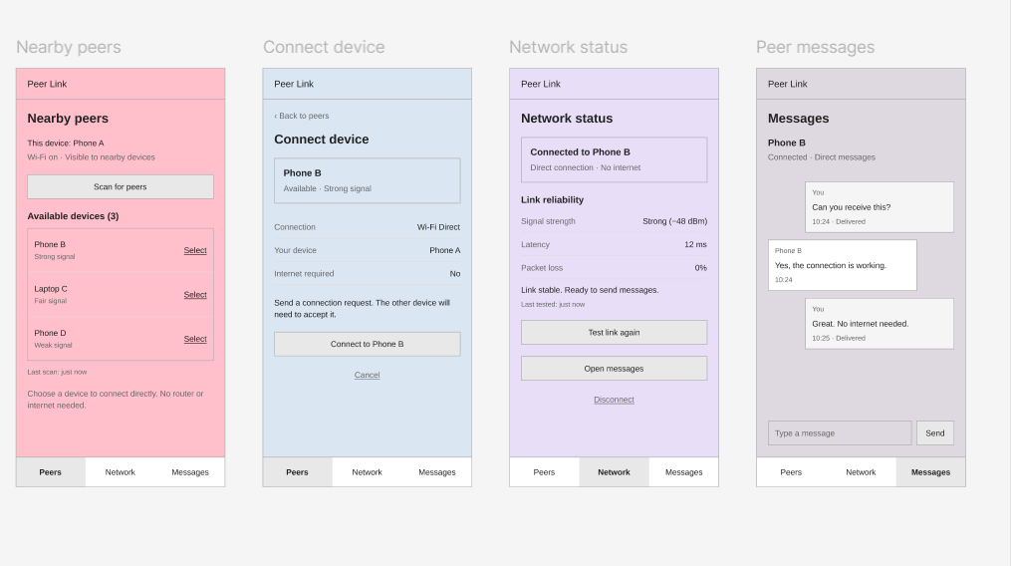

https://www.figma.com/design/i3JkpwWgbaZmHGGB8HGGX7/MC-EXP-15?t=nxOeu3y3fETTOUsO-1

